**1. Calories Burned**

Running on a particular treadmill you burn 4.2 calories per minute. Write a program that uses a loop to display the number of calories burned after 10, 15, 20, 25, and 30 minutes.

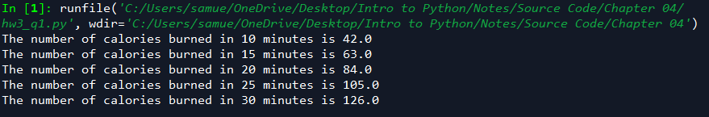

**2. Budget Analysis**

Write a program that asks the user to enter the amount that he or she has budgeted for a month. A loop should then prompt the user to enter each of his or her expenses for the month and keep a running total. When the loop finishes, the program should display the amount that the user is over or under budget.

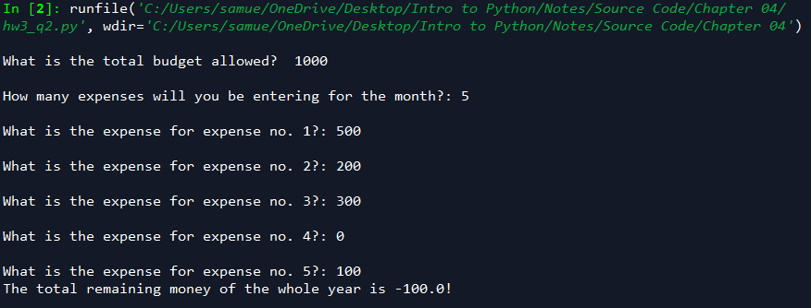

**3. Celsius to Fahrenheit Table**

Write a program that displays a table of the Celsius temperatures 0 through 20 and their Fahrenheit equivalents. The formula for converting a temperature from Celsius to Fahrenheit is

F=95C+32F=95C+32

where *F* is the Fahrenheit temperature, and *C* is the Celsius temperature. Your program must use a loop to display the table.

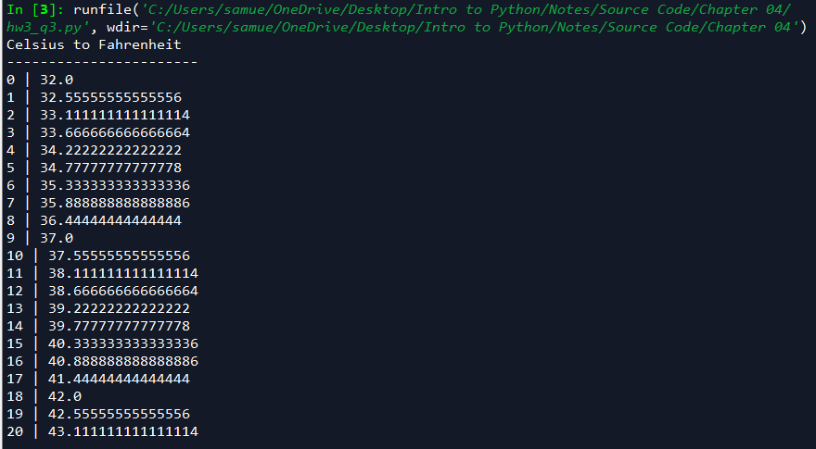

**4. Pennies for Pay**

Write a program that calculates the amount of money a person would earn over a period of time if his or her salary is one penny the first day, two pennies the second day, and continues to double each day. The program should ask the user for the number of days. Display a table showing what the salary was for each day, then show the total pay at the end of the period. The output should be displayed in a dollar amount, not the number of pennies.

